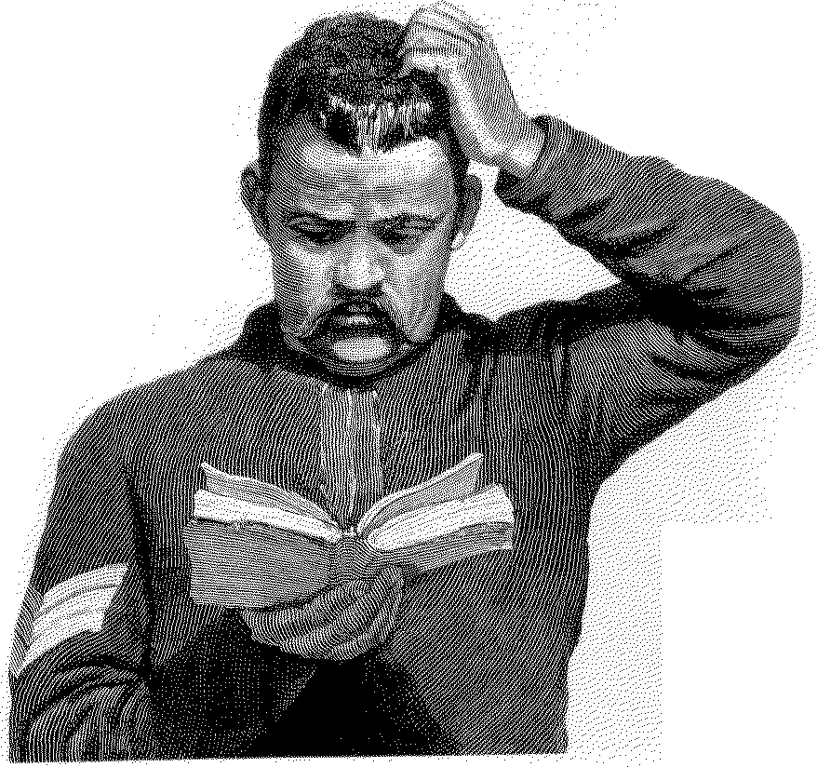
ADVANCEDPLACEMENTENGLISH
S
Poetry Response Assignment

tudents sometimes cringe when they learn that a major focus of this course is poetry. As children most of you loved poetry, reciting nursery rhymes and chanting limericks. What happened ? We don’t have the answer, but one of our goals this year will be to rekindle your enthusiasm for and appreciation of poetry.
Laurence Perrine suggests, “People have read poetry or listened to it or recited it because they liked it, because it gave them enjoyment. But this is not the whole answer. Poetry in all ages has been regarded as important, not simply as one of several alternative forms of amusement, as one person might choose bowling, another, chess, and another, poetry. Rather, it has been regarded as something central to existence, something having unique value to the fully realized life, something that we are better off for having and without which we are spiritually impoverished.”
John Ciardi writes, “Everyone who has an emotion and a language knows something about poetry. What he knows may not be much on an absolute scale, and it may not be organized within him in a useful way, but once he discovers the pleasure of poetry, he is likely to be surprised to discover how much he always knew without knowing he knew it. He may discover, somewhat as the character in the French play discovered to his amazement that he had been talking prose all his life, that he had been living poetry. Poetry, after all, is about life. Anyone who is alive and conscious must have some information about it.”
This year we are approaching poetry two ways. We are studying some poems in class, learning about the tools and devices poets use in their craft, talking about what a poem means or how it made you feel, or seeking answers to questions we raised while reading or studying. We might call this our structured or formal study of poetry. But we are also studying poetry informally through poetry responses.
You will be writing responses about every two weeks. Please look closely at the list of dates to know when these responses are due. You will have a different list of poems each quarter. Your first job is to get to know them. To that end, you will read all the poems from the list at least once every week. Read them at different times, in different places, and in different moods. You will notice how the poems will reveal themselves to you over the weeks. Although you will respond on paper to only one poem for each assignment, you want to become acquainted with all the poems on the list.
For each assignment date, you will choose one poem from the list and write a response to that poem. These responses are to be a minimum of about 200 words, or the equal of one typed page. Place the response in “the box” at the beginning of class on the day it is due. Late poetry reactions do not receive credit.
You may approach this assignment several ways. Sometimes students write an analysis of the poem. They explain what is going on in the poem and relate what they think the theme is. Others begin with the theme and elaborate on that, while some apply the poem to themselves by relating a personal experience. Occasionally a student will write a response on one line from the poem. What you do with the response is up to you as long as you say something. Students who explain that they “could not understand the poem no matter how” they tried do not get credit. You will not like all the poems, but if you choose to write that you dislike a poem because of its content or style, support that with concrete detail.

Adapted from Danny Lawrence;
Career Center, Winston-Salem, North Carolina

Poems for Response: Second Quarter

Choose one of the following poems for each of the poetry responses. All are found in Meyer, The Bedford Introduction to Literature, 8th ed. on the indicated pages. Use a poem once only during the quarter. Write on one poem only for a poetry response.

Yousif al-Sa’igh, “An Iraqi Evening,” p. 1309
Anne Bradstreet, “To My Dear and Loving Husband,” p. 1241
Gwendolyn Brooks, “We Real Cool,” p. 860
Randall Jarrell, “The Death of the Ball Turret Gunner,” p. 832
John Donne, “Death, be not proud,” p. 1058
Linda Pastan, “Pass/Fail,” p. 1252
Seamus Heaney, “The Forge,” p. 1013
Robert Herrick, “To the Virgins, to Make Much of Time,” p. 842
Langston Hughes, “The Negro Speaks of Rivers,” p. 1162
Sharon Olds, “Rites of Passage,” p. 1047
Henry Reed, “Naming of Parts,” 943
Shakespeare, “When, in disgrace with Fortune and men’s eyes,” p. 1344
Shelley, “Ozymandias,” p. 1344
Phillis Wheatley, “On Being Brought from Africa to America,” p. BC-C
William Wordsworth, “The world is too much with us,” p. 1009
William Butler Yeats, “Sailing to Byzantium,” p. 1359

Due Dates

1
2
3
4
5

6
7
8
9
10

